
North Bengal International University

Lab Report: 07
Exp Name : A program postfix calculation in c program .

Subject : Data Structure
Subject Code : CSE 0612-2131

Submitted By:
Name : Md. Tanvir Rahman Pranto
Dept : CSE
Roll : 0712340012101005
Semester : 2nd Year, 4th semester.

Submitted To:
Name : Saifur Rahman
Designation : Lecturer
Dept : CSE
Date :

Code:
#include <stdio.h>
#include <ctype.h>

#define MAX 20

int stack[MAX];
int top = -1;

void push(int x) {
stack[++top] = x;
}

int pop() {
return stack[top--];
}

int main() {
char exp[MAX];
char *e;
int n1, n2, n3, num;

printf("Enter the postfix expression: ");
scanf("%s", exp);

e = exp;

while (*e != '\0') {
if (isdigit(*e)) {
num = *e - '0'; // Convert character to integer
push(num);
} else {
n1 = pop();
n2 = pop();

switch (*e) {
case '+': n3 = n2 + n1; break;
case '-': n3 = n2 - n1; break;
case '*': n3 = n2 * n1; break;
case '/': n3 = n2 / n1; break;
default: printf("Invalid operator\n"); return 1;
}
push(n3);
}
e++;
}

printf("\nThe result of the expression %s = %d\n", exp, pop());

return 0;
}

Output:

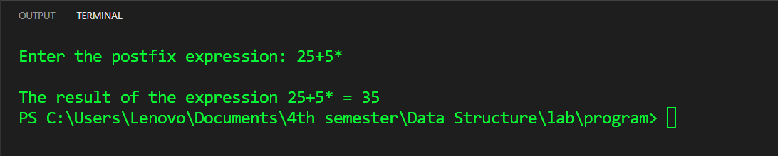

Conclusion: In conclusion, this program successfully evaluates postfix expressions using a stack-based approach. By leveraging isdigit() from , we correctly identify numbers and operators, ensuring proper execution. The use of a structured stack allows for efficient handling of operands and operations, making it a reliable method for postfix evaluation

